Name : Rajvardhan Reddy
Reg No : 180905093
Sec : B
Roll No : 19

CN LAB – 5 : Study of ARP,Subnetting and Supernetting using GNS3

Q5.1) In this exercise you study how the network prefixes (netmasks) play a role when hosts determine if a datagram can be directly delivered or if it must be sent to a router. This part uses the network setup shown in Figure 5.1.

The network includes one router, four hosts and two hubs. The IP addresses of all devices are given in Figure 5.2. Here, each host has only a default route. In other words, the routing table at a host only knows about the directly connected networks and the default gateway.

Exploring the role of prefixes at hosts
In this exercise, you explore how hosts that are connected to the same local area network, but that have different netmasks, communicate or fail to communicate.
(1) Configure the hosts and the router to conform to the topology shown in Figure 5.2, using
the IP addresses as given in Figure 5.2. Note that PC2, PC3, and PC4 have different netmasks.
(2) Add Router1 as default gateway on all hosts. (PC1, PC2, PC3, andPC4).
(3) Issue ping commands from PC1
i) Clear the ARP table on all PCs.
ii) Start Wireshark on PC1 and on PC3, and set the capture filter to capture ICMP and
ARP packets only.
iii) Issue a ping command from PC1 to PC3 for at least two sends (-c2).
iv) Save the output of the ping command at PC1 and the output of Wireshark on PC1
and PC3.
(4) Save the ARP tables, routing tables, and routing caches of each host. Please note that
these are the tables entries from Step 3 after the ping commands are issued.
(5) Issue ping commands from PC3 toPC4
i) Clear the ARP table on all PCs.
ii) Start Wireshark on PC3, and set the capture filter to capture ICMP and ARP packets
only.
iii) Check the ARP table, routing table, and routing cache of each host.
Save the output.
Please note that these are the table entries from Step 4 before the ping is issued.
- Issue a ping command from PC3 to PC4 for at least three sends (-c 3). Save the output of the ping command and the output of Wireshark on PC3. Save the ARP table, routing table, and routing cache of PC3. Please note that these are the table entries from Step 4 after the ping commands are issued.
- Repeat Step 4, but this time issues a ping from PC3 to PC2. Note that once an entry is made in the routing cache, you cannot repeat the previous experiment to obtain the same results. You have to wait until the routing cache is reset or you can delete all the routing caches on all devices.

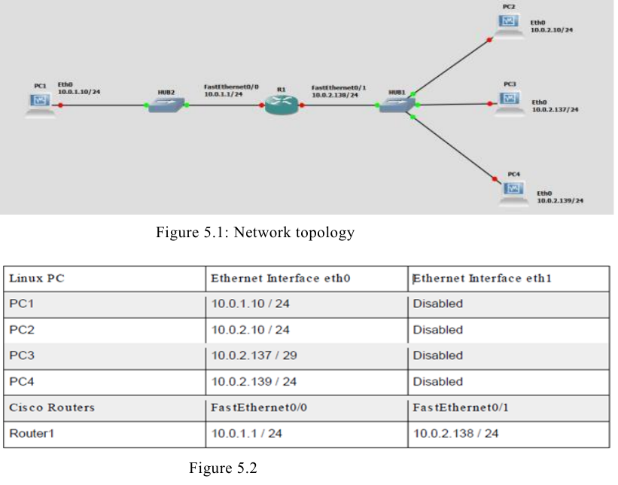

Solution :

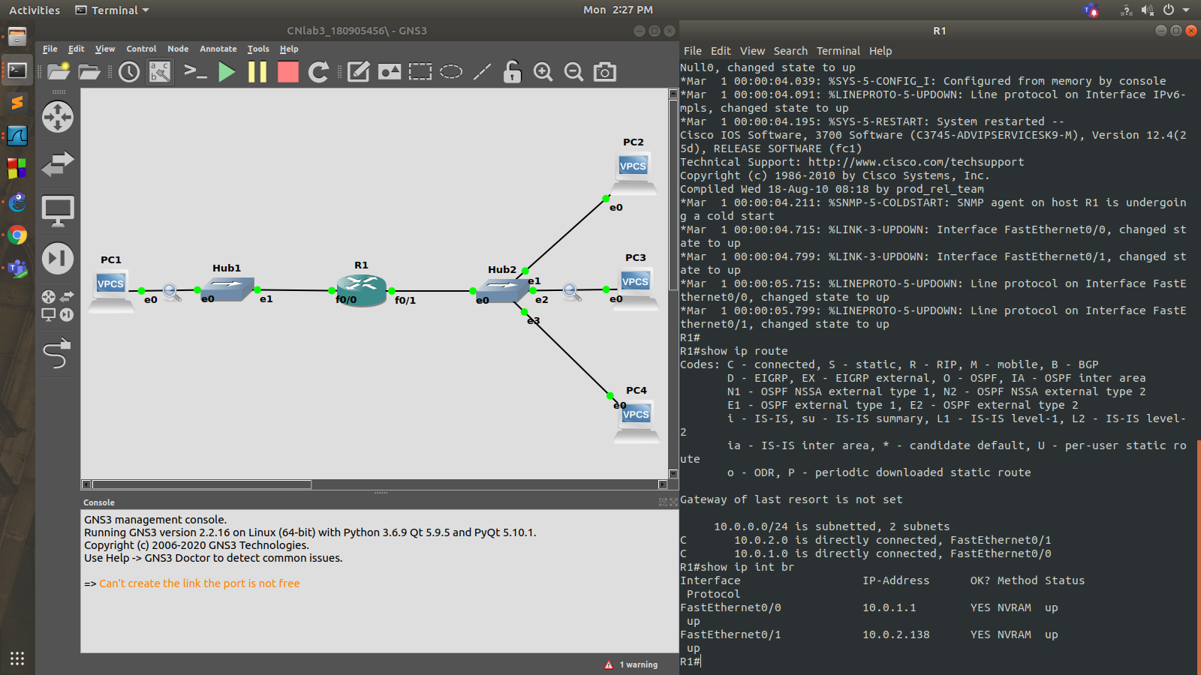
Ping from PC1 to PC3 :

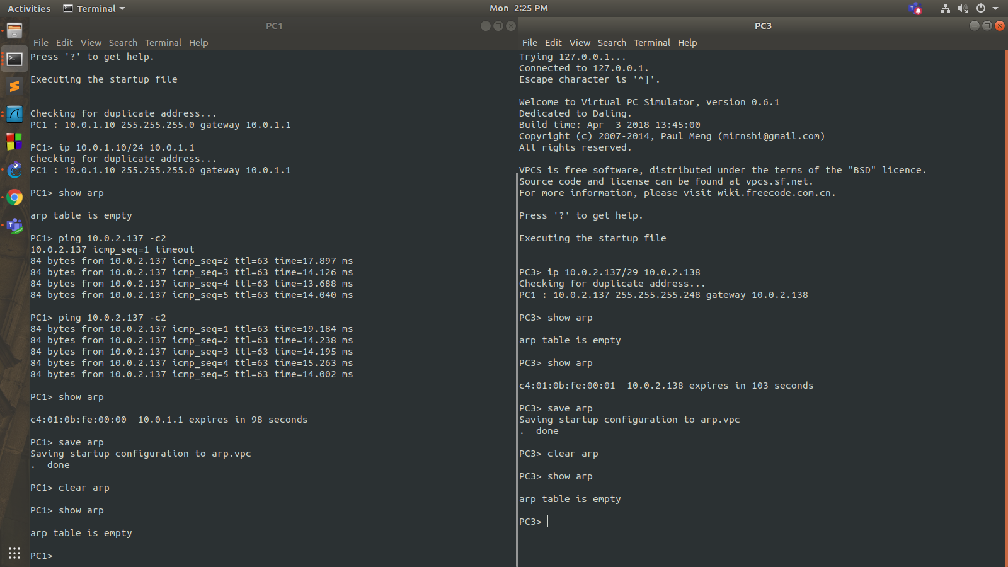

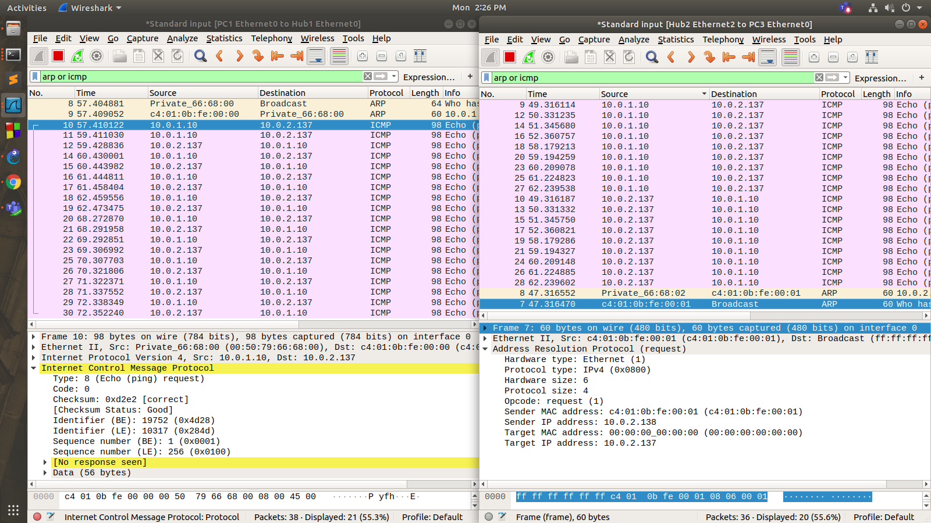

Ping from PC1 to PC2 and PC4 :

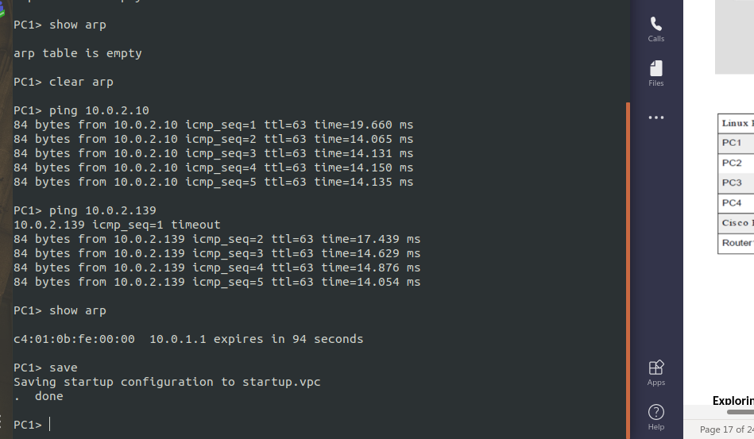

Ping from PC3 to PC4 :
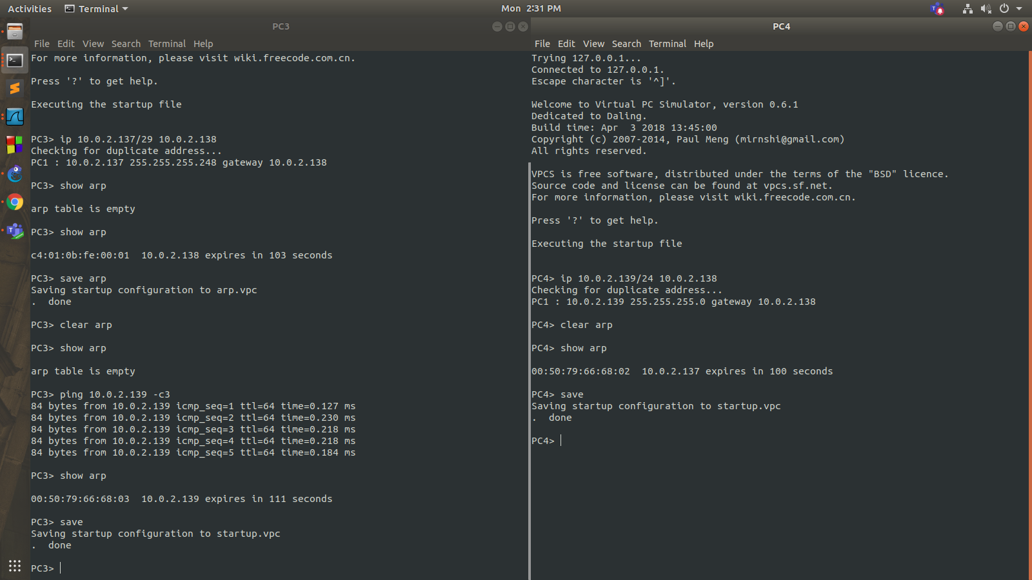
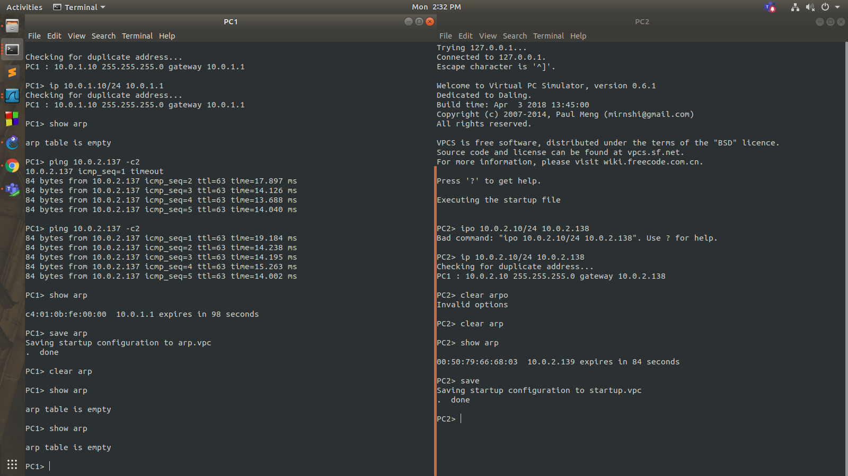
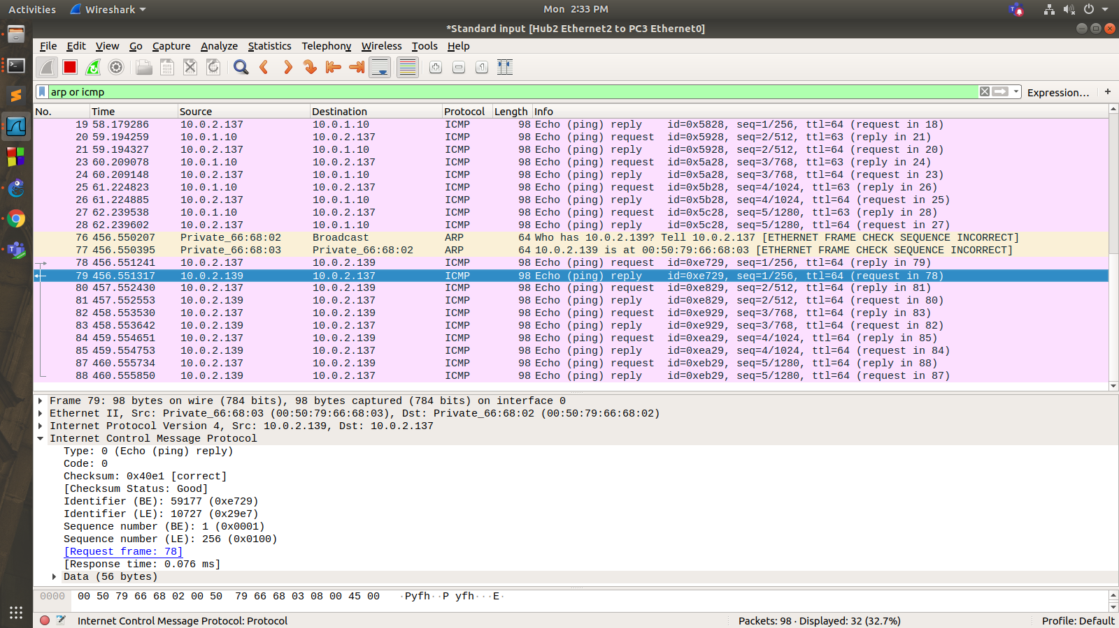

Ping from PC3 to PC2 :
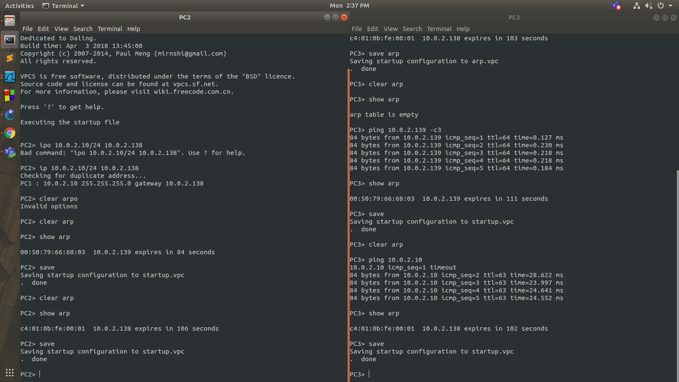

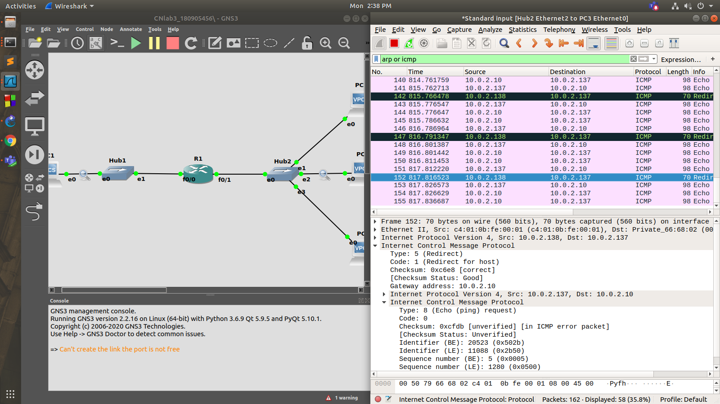

Q2) An organization is granted a block of addresses with the beginning address 14.24.74.0/24. The organization needs to have 3 subblocks of addresses to use in its three subnets: one subblock of 10 addresses, one subblock of 60 addresses, and one subblock of 120 addresses. Design the subblocks. Use the topology shown below.

Allocated no. of address: 232-24 = 256

First address: 14.24.74.0/24; Last address: 14.24.74.255/24
Mask: 255.255.255.0

We should start with largest sub-blocks.
N1=120 => N1=128 => n1=32-log2128 = 25

First address: 14.24.74.0/25
Last address: 14.24.74.127/25 Mask: 255.255.255.128 (as last octet: 1000 0000)

N2=60 => N2=64 => n2=32-log264 = 26
First address: 14.24.74.128/26
Last address: 14.24.74.191/26 Mask: 255.255.255.192 (as last octet: 1100 0000)

N3=10 => N3=16 => n3=32-log216 = 28
First address: 14.24.74.192/28
Last address: 14.24.74.207/28 Mask: 255.255.255.240 (as last octet: 1111 0000)

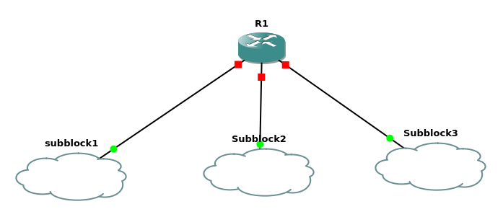

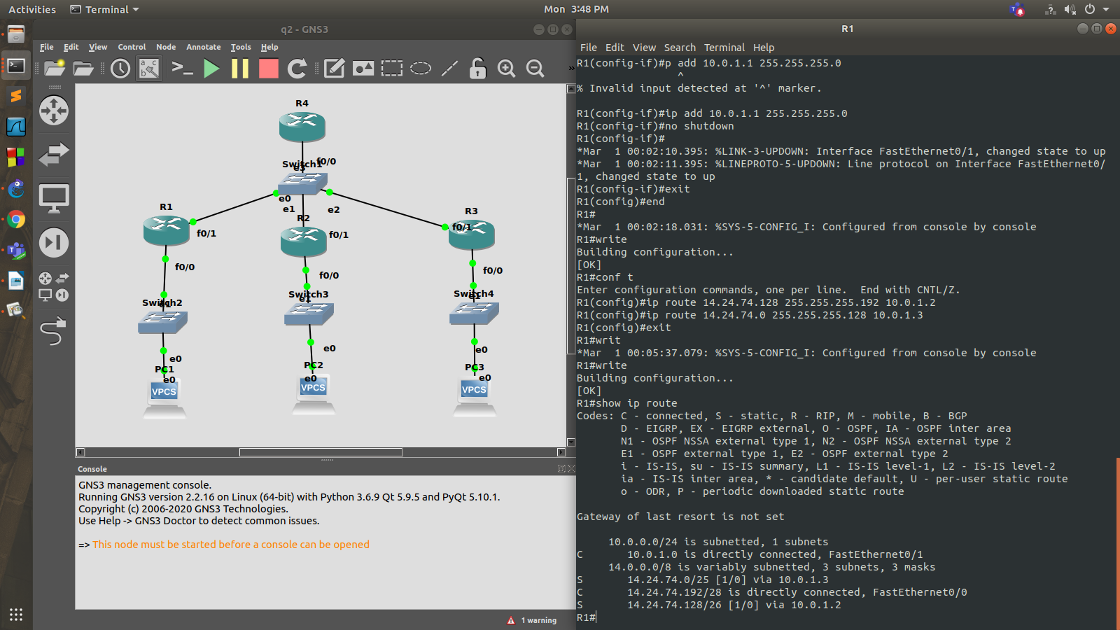

Router configurations:

FOR ROUTER R1 :

R1#enable
R1#conf t
Enter configuration commands, one per line. End with CNTL/Z.
R1(config)#interface f0/0
R1(config-if)#ip add 14.24.74.193 255.255.255.240
R1(config-if)#no shutdown
R1(config-if)#
*Mar 1 00:01:37.895: %LINK-3-UPDOWN: Interface FastEthernet0/0, changed state to up
*Mar 1 00:01:38.895: %LINEPROTO-5-UPDOWN: Line protocol on Interface FastEthernet0/0, changed state to up
R1(config-if)#exit
R1(config)#interface f0/1
R1(config-if)#ip add 10.0.1.1 255.255.255.0
R1(config-if)#no shutdown
R1(config-if)#
*Mar 1 00:02:10.395: %LINK-3-UPDOWN: Interface FastEthernet0/1, changed state to up
*Mar 1 00:02:11.395: %LINEPROTO-5-UPDOWN: Line protocol on Interface FastEthernet0/1, changed state to up
R1(config-if)#exit
R1(config)#end
R1#
*Mar 1 00:02:18.031: %SYS-5-CONFIG_I: Configured from console by console
R1#write
Building configuration...
[OK]
R1#conf t
Enter configuration commands, one per line. End with CNTL/Z.
R1(config)#ip route 14.24.74.128 255.255.255.192 10.0.1.2
R1(config)#ip route 14.24.74.0 255.255.255.128 10.0.1.3
R1(config)#exit
R1#writ
*Mar 1 00:05:37.079: %SYS-5-CONFIG_I: Configured from console by console
R1#write

FOR ROUTER R2:

R2#enable
R2#conf t
Enter configuration commands, one per line. End with CNTL/Z.
R2(config)#interface f0/1
R2(config-if)#ip add 10.0.1.2 255.255.255.0
R2(config-if)#no shutdown
R2(config-if)#
*Mar 1 00:03:07.707: %LINK-3-UPDOWN: Interface FastEthernet0/1, changed state to up
*Mar 1 00:03:08.707: %LINEPROTO-5-UPDOWN: Line protocol on Interface FastEthernet0/1, changed state to up
R2(config-if)#exit
R2(config)#interface f0/0
R2(config-if)#ip add 14.24.74.129 255.255.255.192
R2(config-if)#no shutdown
R2(config-if)#
*Mar 1 00:03:39.551: %LINK-3-UPDOWN: Interface FastEthernet0/0, changed state to up
*Mar 1 00:03:40.551: %LINEPROTO-5-UPDOWN: Line protocol on Interface FastEthernet0/0, changed state to up
R2(config-if)#end
R2#
*Mar 1 00:03:43.811: %SYS-5-CONFIG_I: Configured from console by console
R2#write
Building configuration...
[OK]
R2#conf t
Enter configuration commands, one per line. End with CNTL/Z.
R2(config)#ip route 14.24.74.192 255.255.255.240 10.0.1.1
R2(config)#exit
R2#write
*Mar 1 00:06:25.779: %SYS-5-CONFIG_I: Configured from console by console
R2#write
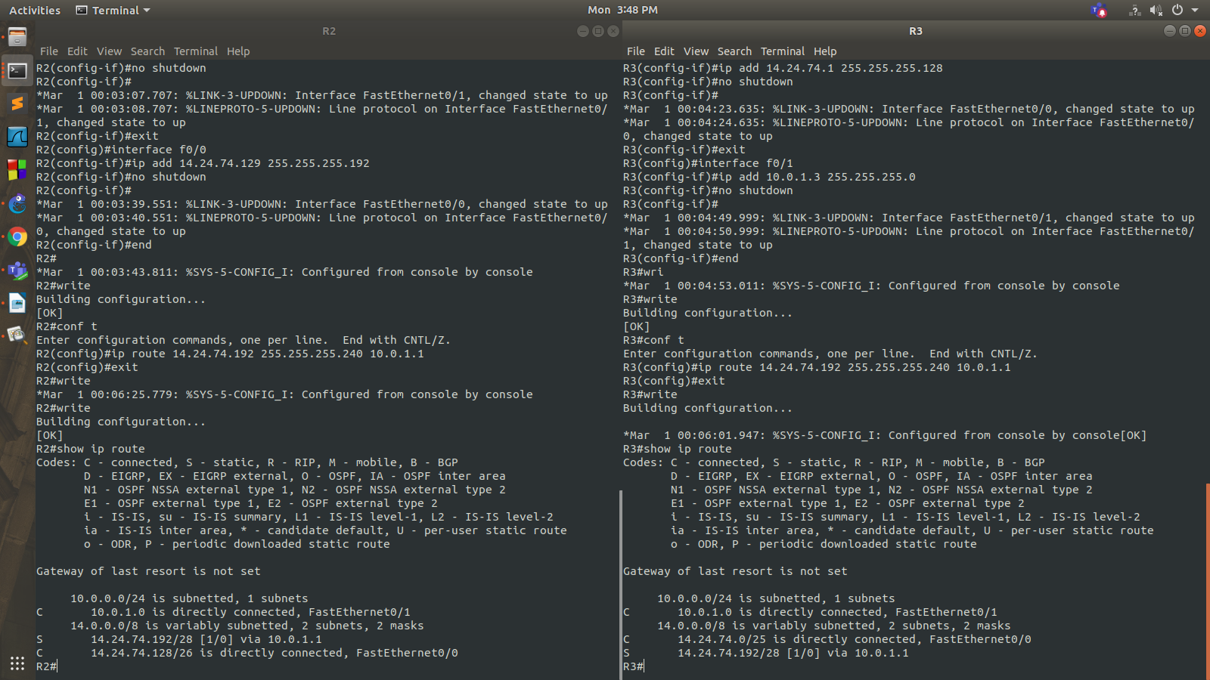

FOR ROUTER R3:

R3#enable
R3#conf t
Enter configuration commands, one per line. End with CNTL/Z.
R3(config)#interface f0/0
R3(config-if)#ip add 14.24.74.1 255.255.255.128
R3(config-if)#no shutdown
R3(config-if)#
*Mar 1 00:04:23.635: %LINK-3-UPDOWN: Interface FastEthernet0/0, changed state to up
*Mar 1 00:04:24.635: %LINEPROTO-5-UPDOWN: Line protocol on Interface FastEthernet0/0, changed state to up
R3(config-if)#exit
R3(config)#interface f0/1
R3(config-if)#ip add 10.0.1.3 255.255.255.0
R3(config-if)#no shutdown
R3(config-if)#
*Mar 1 00:04:49.999: %LINK-3-UPDOWN: Interface FastEthernet0/1, changed state to up
*Mar 1 00:04:50.999: %LINEPROTO-5-UPDOWN: Line protocol on Interface FastEthernet0/1, changed state to up
R3(config-if)#end
R3#wri
*Mar 1 00:04:53.011: %SYS-5-CONFIG_I: Configured from console by console
R3#write
Building configuration...
[OK]
R3#conf t
Enter configuration commands, one per line. End with CNTL/Z.
R3(config)#ip route 14.24.74.192 255.255.255.240 10.0.1.1
R3(config)#exit
R3#write

PC configurations and pinging from PC1 to PC2 and PC3



